13 Nov 11

MEMORANDUM

From: MIDN 1/C Shafiq Ladha, USN

MIDN 2/C Matthew K. McVay, USN  
To: PROF. Parikh

Subj: Motor Lab

1. **Transfer functions:**

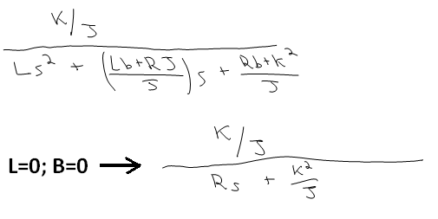

Where K=KτB

1. **MOTOR PARAMETERS**:

|  |  |  |  |  |  |
| --- | --- | --- | --- | --- | --- |
| KDC | Tr | KτB | R | J | Motor TF |
| 1.629 | 0.052 | 0.614 | 2.9 | 0.0030727 | $$\frac{199.8}{2.9*s+122.7}$$ |

The DC gain was computed by dividing the steady state output speed by the input voltage. The rise time was taken from the Speed and time data arrays sent to MATLAB and finding the difference between the time values corresponding to 10% and 90% of the total rise. The motor resistance was measured with an ohmmeter. The motor constant KτB is simply the inverse of the DC gain by inspection of the transfer function. Given the relationship Tr=2.2/|p| , where |p| = (KτB)^2/(R*J), the value of J was solved for using the found and determined values of R, KτB, and Tr. Plugging in all these values gave a numerical transfer function.

1. **ASSUMPTIONS:** For the creation of this model, the motor was assumed to have zero inductance and negligible rotational dampening.
2. **MODEL VALIDATION:**

|  |  |  |  |  |  |  |
| --- | --- | --- | --- | --- | --- | --- |
| Final Voltage | Rise Time(exp) | Rise Time (sim) | % error | DC gain (exp) | DC gain (sim) | % error |
| 3 | 0.052 | 0.052 | 0 | 1.629 | 1.629 | 0 |
| 5 | 0.059 | 0.052 | 11.9 | 1.674 | 1.629 | 2.7 |

Because the model was developed based on the data collected from the 3 Volt input, there was no difference between the rise time and DC gain. However, when the voltage was changed to 5V, the response differed because the invalid assumptions of no dampening or inductance caused a divergence in the response from the model. The second transient was used in both scenarios because the assumptions were more valid for a motor that was already spinning, and the model would not have to account for overcoming the static friction involved in starting a motor.



**3V Response**



**5V Response**

1. **FASTER SPEEDS:** As we increased the speed further, the response diverged further from the model due to the increased importance of induction and increased friction at higher speeds. The motor also has a top speed of 10 rad/sec that cannot be surpassed despite voltage increases.





1. **DISCUSSION:** The assumptions of zero inductance and no dampening inside the motor were more valid for slower speeds, although the computing of DC gain using those assumptions did lead to a small error in the initial value of the model against the 3V input. Therefore, our assumptions affected the model accuracy at all levels, but more so at higher speeds. The model is also only valid for operating speeds under 10 rad/sec.

Very Respectfully,

Shafiq Ladha

MIDN USN

Matthew K. McVay

MIDN USN